* **Welcome to the Healthcare Market Trends & Sickness Dashboard, your interactive tool for exploring real-time data on healthcare spending, illness patterns, and regional health insights.**

* **The second page of the dashboard displays detailed healthcare market trends specific to each ailment, including treatment costs, prevalence rates, and regional variations.**

* **The third page of the dashboard presents a comprehensive view of the healthcare market waitlists, highlighting service delays, patient volumes, and trend changes over time.**

* **The main and welcome page of the Healthcare Market Trends & Sickness Dashboard provides users with tools to begin analyzing disease patterns, healthcare usage, and regional health trends.**

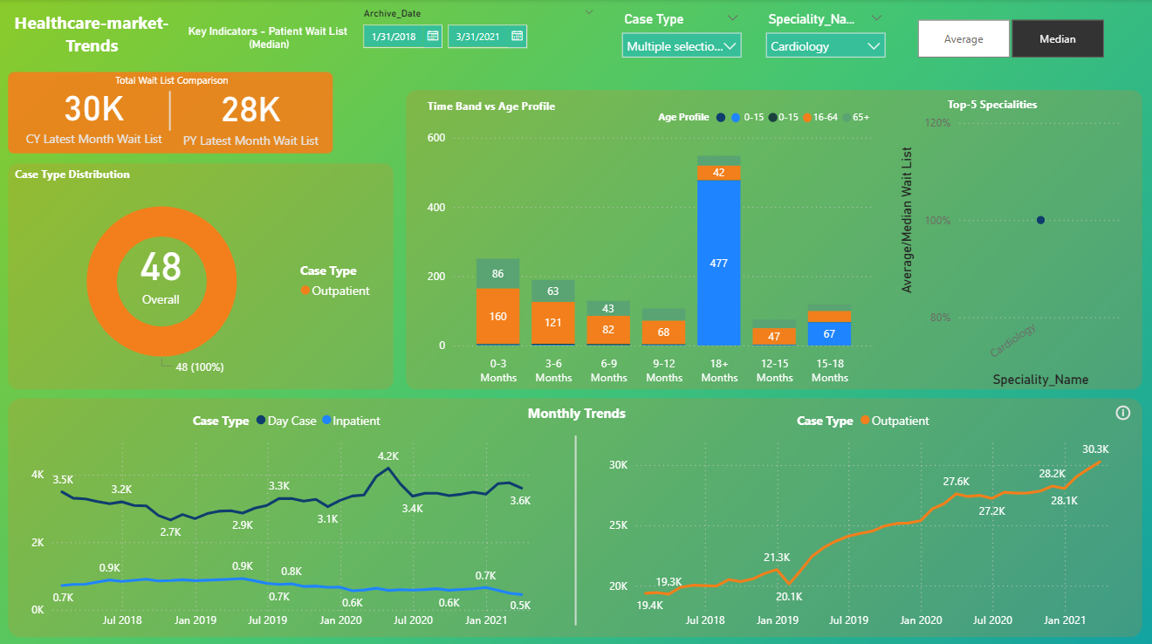

* **The second page of the dashboard highlights healthcare market trends specific to each ailment, enabling users to analyze disease impact, treatment costs, and prevalence patterns.**

* **The third page of the dashboard displays the complete healthcare waitlist data, helping users analyze how service delays relate to disease trends and treatment access.**

* **The page and welcome section offer an entry point into the latest developments and documentation within the healthcare industry.**

* **The home page of the 'Trends in the Healthcare Market' web application introduces users to key insights, tools, and data for exploring industry shifts and emerging healthcare patterns.**

* **The login page provides secure access to the Healthcare Market Trends platform, allowing users to explore personalized insights and data analytics.**

* **Join the "Trends in the Healthcare Market" community to unlock the latest industry insights, data tools, and trends. Create your account now and start exploring the future of healthcare.**

* **Explore personalized healthcare insights, stay informed about the latest trends, and access resources to make better health decisions. Our platform helps you navigate the changing landscape of healthcare with ease and confidence.**

* **Browse through our comprehensive list of healthcare professionals. Filter by specialty, location, and availability to find the right doctor for your needs. Each profile includes qualifications, experience, and patient reviews to help you make an informed decision.**

* **Stay on top of your upcoming appointments. View all your scheduled sessions with doctors, including dates, times, and location details. You can also reschedule or cancel appointments as needed and receive timely reminders to help you never miss a session.**

* **Easily schedule your next appointment with a healthcare provider. Select your preferred doctor, specialty, and available time slot. Fill out a brief form with your health concerns and any necessary information, and confirm your booking instantly. Receive a confirmation and reminder to ensure you’re prepared for your visit.**

* **Customize patient preferences for a personalized healthcare experience.**

* **Update patient details for accurate and up-to-date records.**

* **View patient information for quick reference and review.**

* **Delete account to permanently remove patient data.**

* **View key information and manage patient care on the doctor’s home page.**

* **Manage and schedule patient appointments with ease.**

* **View and manage upcoming patient sessions.**

* **Access and review patient history for informed care.**

* **Customize and manage your account settings.**

* **Monitor activity, manage settings, and oversee platform operations.**

* **View and manage doctor profiles and credentials.**

* **Manage and organize doctor schedules and appointments.**

* **Oversee and manage all patient appointments and doctor availability.**

* **View and manage patient profiles and medical information.**

* **Track and review all platform activities and user actions.**

